**FLOWCHART**

Let’s have a look at the pictorial representation of the FCFS CPU scheduling :

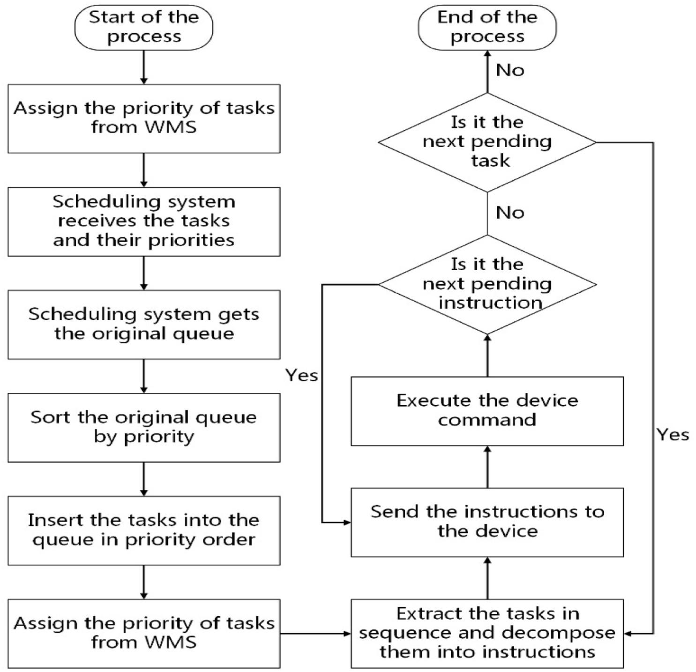

The explanation to the above flowchart is given in the following steps :

**Step 1**: When the WMS scheduling management system issues a task, the scheduling system will receive the task number. If task priority is not specified by users, tasks will automatically get the default lowest priority, otherwise corresponding priority will be assigned to tasks by users.

**Step 2**: The scheduling system calculates the resources required by the tasks and the original scheduling queue of the corresponding resource.

**Step 3**: Sort the tasks in the queue by priority before adding new tasks to the original scheduling queue.

**Step 4**: Insert the above mentioned tasks into the matching positions in the queue ordered by the priority ranking results.

**Step 5**: Transfer the task with the highest priority and the top ranking results in the current queue to the execution queue.

**Step 6**: Decompose these tasks into scheduling instructions.

**Step 7**: The WCS warehouse control system sends the instructions to the specific device resources.

**Step 8:** The device resource executes the instruction and returns to the completion status.

**Step 9**: Execute the next instruction in the sequence.

**Step 10**: End the current task when all instructions for the current task are completed.

**Step 11**: Continue to receive the next task to be executed.

**Step 12**: Complete handling all the tasks and ends the process.

To have even a simpler version of the above mentioned steps we can also resolve our **flowchart** in the following way :

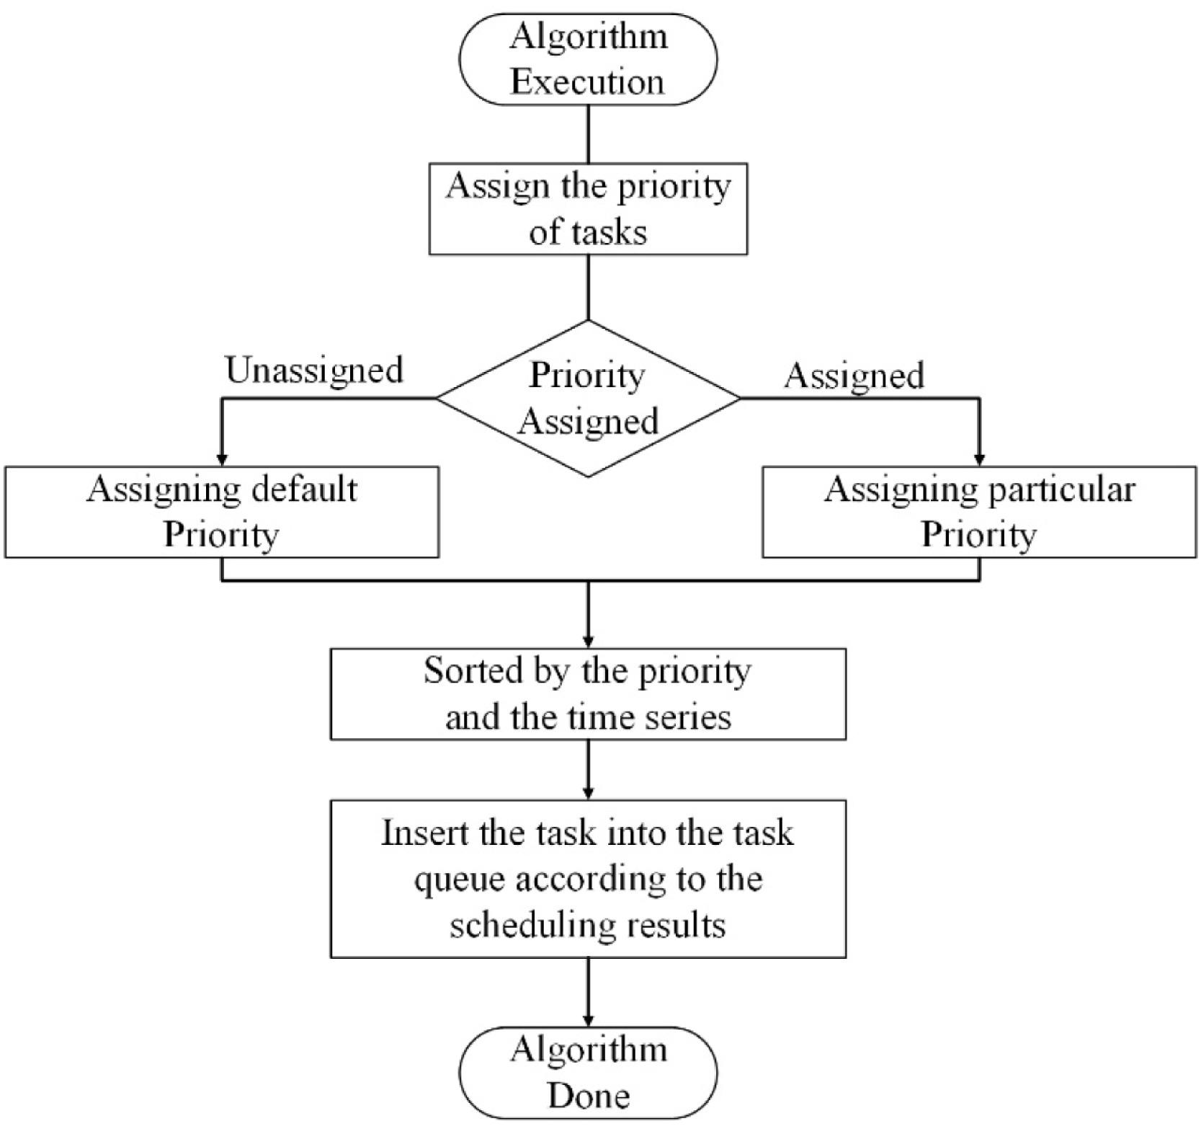

**EXPLANATION :**

**STEP 1 :**The processes can be defined as follows :

Obtain the priority of tasks or use the default priority if no priority is specified.

**STEP 2 :** Add the priority of new tasks to the original scheduling queue and rank the novel task queue according to the priority of tasks.

**STEP3 :**  Insert new tasks into the corresponding position in the queue according to the priority sequential order.

**STEP 4 :** Transfer the task to the execution queue ranked by the priority of tasks.